NFC-IET UNIVERSITY, MULTAN



LAB REPORT

ICT (“Information & Communication Technology Fundamental”)

For the degree of Bacheller of Science

In Computer Science

Session [2k24]

**Name : Kinza Bakhtawar**

**Roll NO : (2k24-BSCS-413)**

**Section : Y**

**Submitted To: MS FABIA HASSAN**

**Submitted By: KINZA BAKHTAWAR**

23 December 2024

LAB 1

**Typing Practice:**

Typing practice is a way to improve your typing speed, accuracy, and efficiency on a keyboard. It involves using various exercises, tools, and techniques to develop muscle memory and familiarity with key placements.

**Example:**

**Typing Master** is the best **software** for typing practice as it helps u to increase your typing speed.

**Internal Components of Computer:**

**1. Central Processing Unit (CPU)**

* **Purpose**:
* Acts as the "brain" of the computer, executing instructions and performing calculations.
* **Components:**
* **Control Unit (CU):** Directs operations of the processor.
* **Arithmetic Logic Unit (ALU):** Performs mathematical and logical operations.

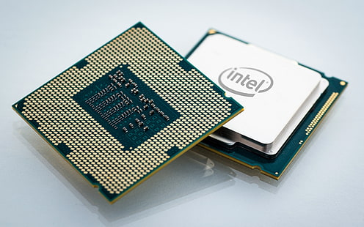

**2. Motherboard:**

* **Purpose:**
* **The main circuit board connecting all components, allowing them to communicate.**
* **Includes: CPU socket, RAM slots, storage connectors, and expansion slots.**

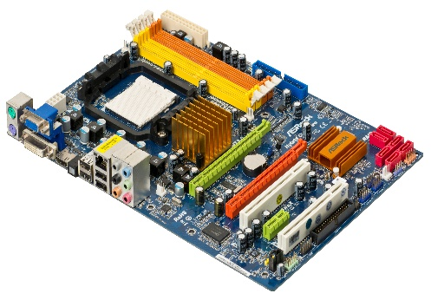

[This Photo](http://commons.wikimedia.org/wiki/file:a790gxh-128m-motherboard.jpg) by Unknown Author is licensed under [CC BY-SA](https://creativecommons.org/licenses/by-sa/3.0/)

**3. Power Supply Unit (PSU):**

* **Purpose:**
* Converts electricity from an outlet into usable power for the computer’s components.
* **Feature:**
* Provides the required voltage and wattage.

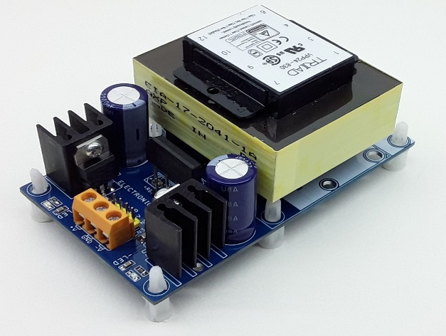

[This Photo](https://www.electronics-lab.com/tag/12v/) by Unknown Author is licensed under [CC BY-SA](https://creativecommons.org/licenses/by-sa/3.0/)

**4. Memory (RAM - Random Access Memory)**

* **Purpose:**
* Temporarily stores data and instructions currently in use by the CPU for quick access.
* **Feature:**
* Volatile memory, meaning data is lost when power is off.

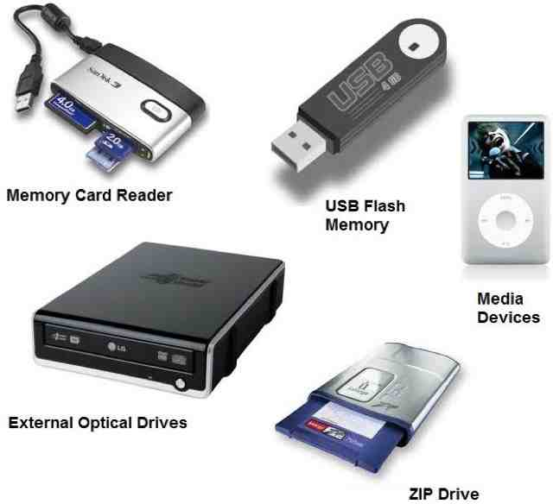

[This Photo](https://tsaponar.blogspot.com/2013/05/) by Unknown Author is licensed under [CC BY-SA](https://creativecommons.org/licenses/by-sa/3.0/)

**LAB 2**

* **Windows installation Steps:**

1. **Prepare:**

* Back up your data.
* Create a bootable USB or DVD with the Windows installer.
* Ensure your PC meets Windows requirements.

1. **Boot from Installation Media:**

* Insert the USB/DVD, restart your PC, and boot from the installation media via BIOS/UEFI settings.

1. **Start Installation:**

* Select language, time, and keyboard preferences.
* Enter the product key (if you have one).

1. **Choose Installation Type:**

* **Upgrade: Keeps files/settings.**
* **Custom: Clean install on a selected partition.**

1. **Install Windows:**

* Wait for files to copy and install. Your PC will restart several times.

1. **Set Up Windows:**

* Configure region, Wi-Fi, and privacy settings.
* Log in with a Microsoft or local account.

1. **Finish Setup:**

* Update Windows, install drivers, and restore files.
  + - CPU Assembling Steps:
* **Prepare Workspace**:

Use a static-free surface and wear an anti-static wrist strap.

1. **Install CPU**:

* Open the CPU socket on the motherboard.
* Align and place the CPU (gold triangle with socket marker).
* Secure it by lowering the lever.

1. **Apply Thermal Paste**:

Add a pea-sized amount if not pre-applied on the cooler.

3. **Attach CPU Cooler**:

* Place the cooler on the CPU and secure it with screws/clips.
* Connect the fan cable to the "CPU_FAN" header.

4. **Install RAM**:

Insert memory modules into motherboard slots.

5. **Mount Motherboard**:

Place it in the case and secure it with screws.

6. **Connect Components**:

Attach PSU cables, storage, GPU, and peripherals.

7. **Power On**:

Turn on the PSU and test the setup.

LAB 3

**Motherboard:**

The **motherboard** is the main circuit board in a computer, connecting and facilitating communication between all components. Here's an overview of its **internal structure** and key components:

* **Internal Structure of a Motherboard:**

1. **Central Processing Unit (CPU) Socket**

* **Purpose**:
  + Holds the CPU and connects it to other components.
* **Types:**
  + Vary depending on CPU brand (e.g., Intel LGA or AMD AM sockets).

1. **Chipset**

* **Purpose:** 
  + Acts as a communication hub between the CPU, memory, storage, and peripherals.
* **Components**:

**Northbridge (older motherboards):**

* + - Manages communication between the CPU, RAM, and GPU.

**Southbridge:**

* + - Manages input/output (I/O) devices, storage, and other peripherals.

1. **Memory (RAM) Slots:**

* **Purpose**:
  + Holds and connects RAM modules for temporary data storage.
* **Types**:
  + DDR3, DDR4, or DDR5 (depends on motherboard generation).

1. **Expansion Slots (PCI/PCIe)**

* **Purpose**:

Allow installation of additional cards like GPUs, sound cards, or network adapters.

* + **Types**:
    - PCIe x16 (for GPUs)
    - PCIe x1 (for smaller cards)

1. **Storage Interfaces**
   * **Purpose**:

Connect storage devices like SSDs or HDDs.

* + **Types**:
    - SATA ports (for traditional SSDs and HDDs)
    - M.2 slots (for NVMe or SATA SSDs)

1. **Power Connectors**:

* **Purpose**:
  + Distribute power from the PSU to the motherboard and components.
  + **Key Connectors**:
    - 24-pin ATX connector (main power)
    - 8-pin CPU power connector.

1. **BIOS/UEFI Chip**
   * **Purpose**:

Stores firmware for booting and hardware initialization.

1. **I/O Ports and Headers**
   * **Purpose**:

Provide connectivity for external devices.

* + **Examples**:
    - USB ports
    - Audio jacks
    - Ethernet ports
    - Display outputs (e.g., HDMI, VGA).

1. **Integrated Peripherals**

* **Purpose**:

Built-in components for specific tasks.

* Examples:
  + - Onboard audio chips for sound.
    - Network Interface Controller (NIC) for internet connectivity.

1. **Cooling System Connectors :**

* **Purpose**:

Provide power to fans and cooling systems.

Includes headers like **CPU_FAN** and **SYS_FAN**.

1. **Internal Buses :**

* **Purpose**:

Data pathways connecting components for communication.

Includes front-side bus (FSB), memory bus, and PCIe lanes.

1. **CMOS Battery:**

* **Purpose**:

Powers the BIOS to maintain system settings like time and date.

LAB 4

**Microsoft Office:**

**Microsoft Office** is a suite of productivity tools for creating documents, spreadsheets, presentations, and more. Here's a concise overview:

* **Main Applications:**

1. **Word:**

For text editing, document creation, templates, and collaboration tools.

1. **Excel:**

For data analysis with formulas, charts, and PivotTables.

1. **PowerPoint**:

For presentations with multimedia, animations, and templates.

1. **Outlook:**

For email, calendar, and task management.

1. **Access**:

For creating and managing databases.

1. **OneNote**:

For digital note-taking and organization.

1. **Teams**:

For communication, video conferencing, and file sharing.

* **Key Features:**
* **Cloud Integration:**

Access and sync files via OneDrive.

* **Collaboration**:

Real-time editing and sharing.

* **Templates**:

Pre-designed layouts for quick, professional results.

* **Security**:

Data encryption and password protection.

* **Automation**:

Macros and tools to save time.

* **Benefits**:

Boosts productivity, easy to use, and works across devices.

**Microsoft Word:**

**Microsoft Word** is a word processing application used for creating, editing, and formatting documents.

* **Key Features of MS Word:**

1. **Text Formatting**:
   * Customize font style, size, color, and spacing.
   * Bold, italic, underline, and strikethrough options.
2. **Paragraph Formatting**:
   * Alignment (left, center, right, justify).
   * Line spacing, indentation, and bullet/numbered lists.
3. **Styles and Themes**:
   * Predefined styles for headings, subheadings, and body text.
   * Document themes for a consistent look.
4. **Templates**:
   * Ready-made templates for resumes, letters, reports, and more.
5. **Insert Objects**:
   * Add images, shapes, charts, tables, and text boxes.
   * Insert hyperlinks, footnotes, headers, and footers.
6. **Collaboration Tools**:
   * Track changes and add comments for collaborative editing.
   * Real-time co-authoring when saved in OneDrive or SharePoint.
7. **Spelling & Grammar Check**:
   * Automatic spelling and grammar correction with suggestions.
   * Thesaurus and translation tools.
8. **Table of Contents**:
   * Automatically generate a table of contents based on document headings.
9. **Review and Editing Tools**:
   * Track changes and accept/reject edits.
   * Compare and merge documents.
10. **Mail Merge**:
    * Create personalized letters, labels, or envelopes by merging data from a spreadsheet.
11. **Cloud Integration**:
    * Save and access documents from OneDrive for online access and sharing
12. **Accessibility Features**:
    * Read aloud, dictation, and translation tools.
    * Accessibility checker to ensure document inclusivity.
13. **Smart Lookup**:
    * Provides definitions, Wikipedia entries, and web searches for highlighted text.

**Benefits:**

* Powerful document creation and formatting tools.
* Collaboration and cloud-based access.
* Widely compatible and professional results.

LAB 5

* 1. **Mail Merge:**
* **Purpose**:

Automates the creation of personalized documents (e.g., letters, labels) using data from an external source (like Excel).

* + **Steps**:
* **Start Mail Merge**:

Go to **Mailings > Start Mail Merge** and select the document type (e.g., Letters).

* **Select Recipients**:

Click **Select Recipients** to choose a data source (Excel file, CSV, etc.).

* **Insert Merge Fields**:

Place placeholders like name or address using **Insert Merge Field**.

* **Finish & Merge**:

Complete the merge by clicking **Finish & Merge**, then select **Print** or **Create New Document**.

* 1. **Table of Contents (TOC):**
* **Purpose**:

Automatically creates a TOC based on the headings in the document.

**Steps**:

* **Apply Heading Styles**:

Use **Heading 1**, **Heading 2**, etc., for section titles.

* **Insert TOC**:

Go to **References > Table of Contents** and choose a style.

* **Update TOC**:

After changes, right-click the TOC and select **Update Field** to reflect edits.

**3. Section Breaks:**

**Purpose**:

Divides a document into sections, allowing different formatting, headers/footers, and page numbering within the same document.

* **Types of Section Breaks**:
* **Next Page**:

Starts a new section on the next page.

* **Continuous**:

Starts a new section on the same page.

* **Odd/Even Page**:

Starts a new section on the next odd/even page.

* **Steps**:
* **Go to Layout > Breaks**, then choose the type of **Section Break**.

**4.References:**

* **Purpose**:

Adds citations, footnotes, endnotes, and bibliographies to a document.

* **Steps**:
* **Insert Citation**:

Go to **References > Citations & Bibliography**, then click **Insert Citation** and choose your source.

* **Add Footnotes/Endnotes**:

Click **Insert Footnote** or **Insert Endnote** under the **References** tab.

* **Manage Sources**:

Use **Manage Sources** to store and organize references for future use.

**5. Headers and Footers:**

* **Purpose**:

Adds content that appears at the top (header) or bottom (footer) of each page (e.g., page numbers, document title, author name).

* **Steps**:
* **Insert Header/Footer**:

Go to **Insert > Header** or **Insert > Footer**, and choose a style.

* **Edit Content**:

You can insert text, page numbers, date, or images.

* **Different Headers/Footers for Sections**:

Use **Link to Previous** to enable or disable the same header/footer across sections. To edit a specific section, uncheck **Link to Previous** under the **Header & Footer Tools** tab.

* **Page Numbering**:

Click **Page Number** under the **Insert** tab to place page numbers in headers/footers.

* **Efficient Usage Tips:**
* **Mail Merge**:

Always use an Excel spreadsheet for organizing recipient data and ensure it’s formatted properly before starting the merge.

* **TOC**:

To get the best results, consistently apply heading styles for all section titles in your document.

* **Section Breaks**:

Use them when you need different page orientations (portrait vs. landscape) or separate page numbering formats (e.g., Roman numerals for front matter, numbers for the rest).

* **References**:

Use **Source Manager** to keep a library of citations for future use, and select the correct citation style (APA, MLA, etc.) under **References > Style**.

* **Headers/Footers**:

For documents with multiple sections, ensure each section has the correct header/footer by checking the **Link to Previous** option.

**LAB 6**

### ****1. Mendeley (Reference Management and Citation Tool):****

**Purpose**:

Mendeley helps manage and organize your research papers, create citations, and generate bibliographies.

**Features**:

* **Reference Management**:

Import research papers from academic databases like Google Scholar, JSTOR, and more.

* **Citations**:

Automatically generate citations in various formats (APA, MLA, Chicago, etc.).

* **Bibliography Generation**:

Create bibliographies by selecting references in your Mendeley library.

* **Collaboration**:

Share references and documents with teams for collaborative work.

**Steps**:

1. **Install Mendeley**:

Download and install Mendeley Desktop from [Mendeley’s website](https://www.mendeley.com).

1. **Add Documents**:

Import PDFs or manually add references using the "Add Document" option.

1. **Use Mendeley with Word**:

Install the Mendeley Word Plugin to easily insert citations and generate bibliographies.

* + **Insert Citations**:

Click **References > Insert Citation** and search your Mendeley library.

* + **Generate Bibliography**:

Once all citations are added, Mendeley can create a bibliography with the **Insert Bibliography** button.

### ****2. Grammarly (Grammar and Writing Assistance):****

**Purpose**:

Grammarly helps with grammar checking, spelling correction, style improvement, and plagiarism detection.

**Features**:

* **Grammar Check**:

Checks for spelling, grammar, punctuation errors, and clarity.

* **Writing Style**:

Suggestions to improve sentence structure and readability.

* **Plagiarism Detection**:

Checks if content matches sources online.

* **Tone Detection**:

Analyzes the tone of your writing (formal, casual, etc.).

**Steps**:

1. **Install Grammarly**:

Download the Grammarly plugin for your browser, or use the desktop app.

1. **Use in Word**:

Grammarly integrates with Microsoft Word and Outlook to check grammar while you write.

1. **Proofread**:

Review suggestions in the Grammarly sidebar and accept/reject them as needed.

### ****PDF Element (PDF to Word Conversion Tool):****

**Purpose**:

PDF Element allows for PDF editing and converting PDFs into Word, Excel, PowerPoint, and more.

**Features**:

* **PDF to Word**:

Convert PDFs into editable Word documents without losing formatting.

* **Editing PDFs**:

Add, delete, or modify text and images in PDFs.

* **Form Filling**:

Fill out PDF forms and save them.

* **OCR (Optical Character Recognition)**:

Convert scanned documents into editable formats.

**Steps**:

1. **Install PDF Element**: Download and install PDF Element from Wondershare's website.
2. **Convert PDF to Word**:
   * Open the PDF in PDF Element.
   * Click on **Convert** and select **To Word**.
3. **Edit PDF**:

Use the **Edit** tab to modify text, images, or add annotations.

1. **OCR**:

If the PDF is a scanned image, use the **OCR** feature to extract editable text.

### ****4. Automating Repetitive Tasks with Macros in Word:****

**Purpose**:

Macros automate repetitive tasks in Word, saving time on tasks like formatting, text insertion, etc.

**Steps to Create a Macro**:

1. **Record a Macro**:
   * Go to **View > Macros > Record Macro**.
   * Name your macro and assign a shortcut key.
   * Perform the tasks you want to automate (e.g., formatting text, inserting headers).
2. **Stop Recording**:
   * After completing the actions, click **View > Macros > Stop Recording**.
3. **Run a Macro**:
   * To run your macro, use the shortcut key or go to **View > Macros > View Macros**, select your macro, and click **Run**.

### ****5. Referencing Tools for Citations, Footnotes, and Endnotes****

**Purpose**:

These tools help you create proper citations, footnotes, and endnotes within Word documents.

**Steps**:

* **Insert Citations**:
  1. Use **References > Citations & Bibliography** to insert citations from your selected referencing style.
  2. Click **Insert Citation** to choose or add a source.
* **Insert Footnotes/Endnotes**:
  1. Go to **References > Insert Footnote** to insert footnotes.
  2. For endnotes, click **Insert Endnote**. Both footnotes and endnotes will be numbered automatically.
* **Manage Sources**:

Use **Manage Sources** to store and edit your citations for future use in documents.

LAB 7

**1. Mail Management:**

Efficient email handling is critical for productivity. Here are some tips and tools:

**Key Features & Best Practices**

* **Folder Organization:**
  + Use folders or labels to categorize emails (e.g., by project, client, or urgency).
  + Automate email sorting using rules or filters.
* **Search & Archive:**
  + Leverage search tools to quickly locate old emails.
  + Archive emails that are not immediately needed but must be retained.
* **Flags & Reminders:**
  + Use flags or stars to highlight important emails.
  + Set reminders for emails requiring a response or follow-up.
* **Unsubscribe & Declutter:**
  + Regularly unsubscribe from irrelevant mailing lists.
  + Use tools like Clean Email or Unroll.me to manage subscriptions.
* **Unified Inbox:**
  + Use apps that consolidate multiple email accounts (e.g., Outlook, Thunderbird).

**Popular Tools for Mail Management:**

* **Microsoft Outlook:**
* Includes rules, categories, and a focused inbox for prioritizing emails.
* **Gmail:**
* Offers smart filters, labels, and AI-driven priority inbox.
* **Spark:**
* A collaborative email app that supports team discussions within emails.

**2. Collaborative Tools:**

Collaborative platforms enhance teamwork, especially for remote or hybrid settings.

**Key Features:**

* **Track Changes & Comments:**
  + Enable "Track Changes" to show edits made by collaborators.
  + Add comments for clarification, suggestions, or discussions directly within the document.
* **Real-Time Collaboration:**
  + Use tools that allow multiple users to work simultaneously.
  + Ensure version history is enabled for tracking progress.
* **Task Assignments:**
  + Assign tasks or portions of a project within the document itself (e.g., in Google Docs or Microsoft Word).

**Popular Tools for Collaboration:**

* **Microsoft 365 (Word, Excel, PowerPoint):**
* Offers robust commenting, change tracking, and versioning features.
  + **Google Workspace (Docs, Sheets, Slides):**
* Known for real-time collaboration and ease of sharing.
  + **Notion/Click Up:**
* Combines documents with project management features.

1. **Document Protection:**

Safeguarding sensitive information is essential, especially when sharing documents.

**Key Features:**

* **Password Protection:**
  + Set strong passwords for documents (e.g., in Microsoft Word or Adobe Acrobat).
* **Editing Permissions:**
  + Restrict access to view-only, comment-only, or full editing rights.
  + Use "share with specific users" rather than public links.
* **Watermarking:**
  + Add watermarks to prevent unauthorized distribution or copying.
* **Track Changes During Reviews:**
  + Ensure all edits are visible for accountability.
  + Lock certain sections from editing if necessary.

**Tools for Protection:**

* + **Microsoft Office Suite:**
* Password-protect documents and control editing permissions.
  + **Adobe Acrobat:**
* Provides advanced PDF protection features like encryption and restricted access.
  + **Google Drive:**
* Allows sharing controls, such as expiry dates for access links.

**Mastering Reviewing and Comparing Documents:**

* Use **Microsoft Word** or **Adobe Acrobat** to compare two versions of a document, highlighting differences.
* **In Microsoft Word:**
  + Go to **Review** > **Compare** > Choose documents to compare.
* **In Adobe Acrobat:**
  + Use **Compare Files** for PDFs, highlighting changes between versions.

LAB 8

**📊 Excel Essentials Guide**

**Master Excel Skills for Data Management and Analysis**

**1. 🌟 Getting Started with Excel:**

**🔸 What is Excel?**

* A spreadsheet tool used for data entry, analysis, and visualization.

**🔸 Key Excel Elements**

* **Workbook & Worksheets:**

Files with multiple sheets.

* **Excel Interface:**

Ribbon, Quick Access Toolbar, Formula Bar, and Status Bar.

**🔸 Basic Actions**

* **Create a New Workbook:**

File → New → Blank Workbook

* **Save Your Work:**

File → Save As

**📸 Suggested Picture:**

Screenshot showing Excel's interface with key areas labeled.

**2. 📐 Intermediate Formulas & Functions**

**🔹 Working with Multiple Worksheets:**

* **Add/Delete Sheets:**

Click "+" or right-click tab → "Delete"

* **Rename Sheets:**

Double-click the tab name.

* **Link Data Across Sheets:**

Use =Sheet2!A1 in formulas.

**📸 Suggested Picture:**

Example of linked worksheets referencing data.

**🔹 Key Excel Functions:**

**🔹 Key Excel Functions:**

|  |  |  |
| --- | --- | --- |
| **Function** | **Description** | **Example** |
| **=MIN(range)** | **Finds the smallest value** | **=MIN(A1:A10)** |
| **=MAX(range)** | **Finds the largest value** | **=MAX(A1:A10)** |
| **=COUNT(range)** | **Counts numbers only** | **=COUNT(A1:A10)** |
| **=IF(condition, true, false)** | **Conditional check** | **=IF(A1>50, "Pass", "Fail")** |

**📸 Suggested Picture:**

Excel table with formulas applied, showing results.

**3. 🔗 Cell Referencing Basics:**

**🔹 Types of Cell Referencing:**

1. **Relative Referencing:**
   * Adjusts automatically when copied.

* Example:

=A1+B1

1. **Absolute Referencing:**
   * Fixed using $ symbol.

* Example:

=$A$1+$B$1

1. **Mixed Referencing:**
   * Combines both methods.

* Example:

=$A1+B$1

**📸 Suggested Picture:**

Visual showing the effect of copying formulas with different referencing types.

**4.📋 Sorting & Filtering Data:**

**🔹 Sorting Data**

* **Steps to Sort:**
  + Select your data range.
  + Click **Data → Sort**.
  + Choose columns, sort by ascending/descending.

**🔹 Filtering Data:**

* **Steps to Filter:**
  + Select data range.
  + Click **Data → Filter**.
  + Use drop-down arrows to filter specific values.

**📸 Suggested Picture:**

Data being sorted and filtered in Excel, with dialogs highlighted.

LAB 9

**1. 📈 Creating Charts and Graphs:**

**🔹 Why Use Charts?**

* Make data easier to interpret.
* Identify trends, patterns, and comparisons visually.

**📊 Popular Excel Chart Types:**

1. **Bar Chart:**

Compare categories side by side.

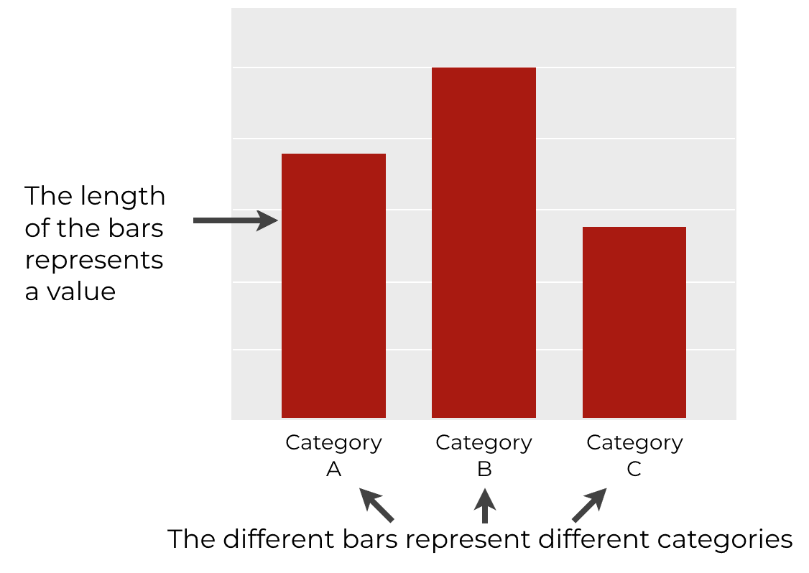

1. **Line Chart:**

Show trends over time.

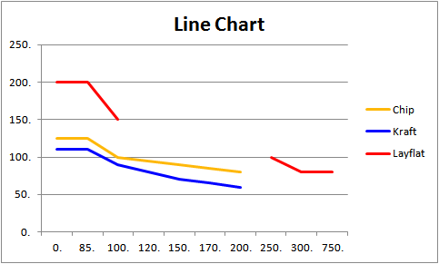

1. **Pie Chart:**

Display proportions as slices of a circle.

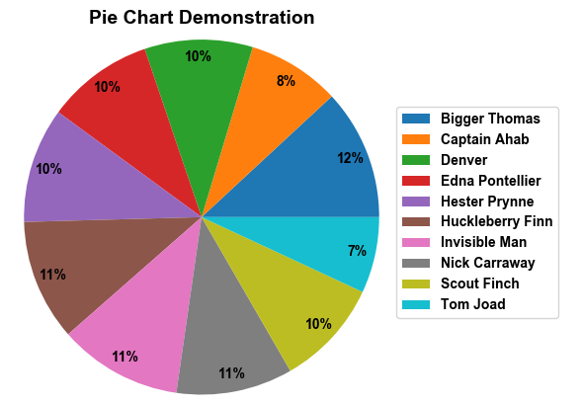

**📋 How to Create a Chart:**

1. Select your data range.
2. Click **Insert → Charts** from the Ribbon.
3. Choose your chart type (Bar, Line, Pie).
4. Customize titles, legends, and labels.

**💡 Pro Tip:**

**Use the Chart Design tab for custom styles and layouts.**

**📸 Suggested Visual:**

Examples of different Excel charts created from sample data.

**2. 🎨 Conditional Formatting:**

**🔹 What Is Conditional Formatting?**

Highlight important data visually by applying colors, icons, or bars based on conditions.

**📋 How to Apply Conditional Formatting:**

1. Select the data range.
2. Go to **Home → Conditional Formatting**.
3. Choose a rule (e.g., "Highlight Cells Greater Than").
4. Set your desired formatting style (color, bold text, data bars, or icons).

**Example Rules:**

* **Sales Targets:**

Highlight sales over $5,000 in green.

* **Top Performers:**

Use color scales to indicate performance.

**📸 Suggested Visual:**

A spreadsheet with applied conditional formatting showing color-coded cells.

**3. 🏷️ Creating Barcodes and QR Codes:**

**🔹 Why Use Barcodes and QR Codes?**

* Automate product tracking, inventory management, or event registration.

**📋 How to Create Barcodes and QR Codes:**

1. **For Barcodes:**
   * Install **Code 39 Font** or similar.
   * Enter the product ID and apply the barcode font.



1. **For QR Codes:**
   * Go to **Insert → Get Add-ins**.
   * Search and install **QR4Office**.
   * Generate QR codes by entering data directly.

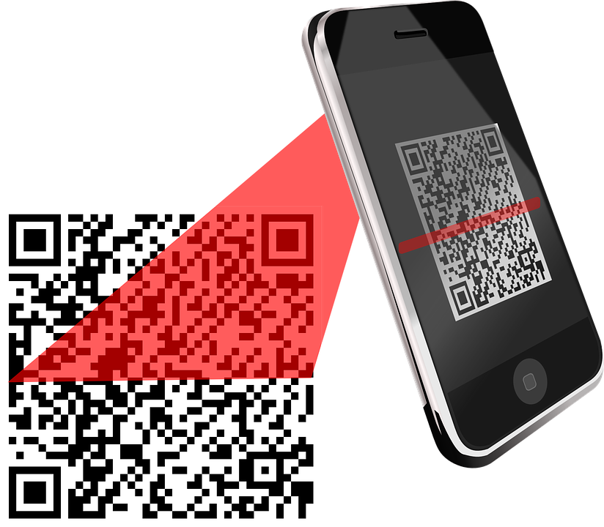

**💡 Pro Tip:**

Use QR codes for product details, web links, and contact info!

**📸 Suggested Visual:**

Generated barcodes and QR codes with example labels.

**4. 📋 Working with Tables and Data Validation:**

**🔹 Why Use Tables?**

* Organize and format data efficiently.
* Enable filtering, sorting, and automatic formulas.

**📋 How to Create a Table:**

1. Select the data range.
2. Click **Insert → Table**.
3. Check “Table has headers” if applicable.

**🔹 Applying Data Validation:**

* Ensure only specific types of data are entered.

**📋 Steps:**

1. Select the target cells.
2. Go to **Data → Data Validation**.
3. Choose the validation type (e.g., list, whole number, or date).
4. Customize the error message if needed.

* **Example Use Cases:**
* **Dropdown Menus:**

Create dropdown lists for selection.

* **Input Restrictions:**

Limit age to numbers between 18-60.

**📸 Suggested Visual:**

A well-formatted Excel table with dropdown lists and data validation alerts.

**5. 📊 Statistical Analysis Functions:**

**🔹 Why Use Statistical Functions?**

* Perform data analysis and generate insights quickly.

**📋 Key Excel Statistical Functions:**

|  |  |  |
| --- | --- | --- |
| **Function** | **What It Does** | **Example** |
| =AVERAGE(range) | Calculates the average value. | =AVERAGE(A1:A10) |
| =MEDIAN(range) | Finds the middle value. | =MEDIAN(A1:A10) |
| =MODE.SNGL(range) | Returns the most common value. | =MODE.SNGL(A1:A10) |
| =STDEV.P(range) | Standard deviation (pop.). | =STDEV.P(A1:A10) |
| =VAR.P(range) | Variance of a population. | =VAR.P(A1:A10) |
| =COUNTIF(range,criteria) | Counts values matching criteria. | =COUNTIF(A1:A10, ">50") |

**6. 📊 Frequency Function for Data Analysis:**

**🔹 Why Use the FREQUENCY Function?**

* Analyze how often specific values appear in a dataset.

**📋 How to Use FREQUENCY Function:**

1. Enter data values in **A2:A11** (e.g., exam scores).
2. Define intervals (bins) in **B2:B5** (e.g., 0-50, 51-70, etc.).
3. Use this array formula (Ctrl + Shift + Enter):

=FREQUENCY(A2:A11, B2:B5):

**Result:**

The result shows how many scores fall within each bin range.

**📸 Suggested Visual:**

A table showing score frequency analysis with bins and corresponding results.

LAB 10

**📊 Advanced Tools and Final Project in Excel:**

**1. 📋 Introduction to Pivot Tables**

**🔹 Why Use Pivot Tables?**

* Summarize, analyze, and explore data quickly.
* Create customized reports without altering the original data.

**📋 How to Create a Pivot Table:**

1. Select your data range.
2. Go to **Insert → Pivot Table**.
3. Choose where to place the table (New/Existing worksheet).
4. Drag fields to **Rows**, **Columns**, **Values**, and **Filters**.

**Example Use Case:**

* **Sales Report Analysis:** Summarize total sales by month, region, or product.

**📸 Suggested Visual:**

A Pivot Table summarizing monthly sales with categories and totals.

**2. 🔍 Using VLOOKUP and HLOOKUP:**

**🔹 What Are VLOOKUP and HLOOKUP?**

* **VLOOKUP:** Finds data vertically in a column.
* **HLOOKUP:** Searches horizontally in a row.

**📋 VLOOKUP Syntax:**

* excel
* Copy code

=VLOOKUP(lookup_value, table_array, col_index_num, [range_lookup])

**Example:**  
Find a product's price from a product list:

|  |  |
| --- | --- |
| **Product** | **Price ($)** |
| Laptop | 1000 |
| Phone | 800 |

**Formula:**

=VLOOKUP("Laptop", A2:B4, 2, FALSE)

**Result:** $1000

**📋 HLOOKUP Syntax:**

=HLOOKUP(lookup_value, table_array, row_index_num, [range_lookup])

**Example:**  
Find the sales in **March** from a table:

|  |  |  |  |
| --- | --- | --- | --- |
| **Month** | **January** | **February** | **March** |
| Sales ($) | 5000 | 7000 | 6500 |

**Formula:**

=HLOOKUP("March", A1:D2, 2, FALSE)

**Result:**

$6500

**📸 Suggested Visual:**

Tables with sample lookup results displayed.

**3. 🏗️ Introduction to Macros:**

**🔹 Why Use Macros?**

* Automate repetitive tasks.
* Increase productivity and reduce manual errors.

**📋 How to Create a Macro:**

1. Go to **Developer → Record Macro**.
2. Name the macro and choose where to store it.
3. Perform the actions you want Excel to record.
4. Click **Stop Recording**.

**Running a Macro:**

* Use **Alt + F8** or assign the macro to a button.

**💡 Example Task Automation:**

* Format a report automatically (adjust font, add headers, apply styles).

**📸 Suggested Visual:** Macro recording window with a task being automated.

1. **📊 Final Project: Analyze and Visualize Data Set:**

**🔹 Project Goal:**

Use the skills learned throughout the course to analyze and visualize a real-world dataset.

**💡 Project Idea:**

**Sales Data Analysis Project:**

1. **Data Source:**

Use sales data (products, prices, regions, and sales amounts).

1. **Tasks:**
   * Create a **Pivot Table** summarizing sales by region.
   * Use **VLOOKUP** to fetch product details.
   * Apply **Conditional Formatting** to highlight high sales.
   * Generate **Charts**: Bar, Line, and Pie Charts.
   * Create a **Dashboard** combining Pivot Tables and Charts.
   * Automate report generation with **Macros**.

**📸 Suggested Visual:**

A dashboard showing sales analysis with pivot tables, charts, and lookup results.

**PRACTICAL WORK OF MS WORD FEATURES PERFORMED IN LAB**

**Home 🡪 create a new document , Recent and pinned projects**

**New🡪 ctrl +N (for new blank document)**

**Open 🡪 ctrl + O (opening a new document)**

**Info 🡪 (tells us about privacy related to created document)**

**Save 🡪 ctrl +S (saving document)**

**Save as 🡪 ctrl +S (saving document)**

**Print 🡪 ctrl +P (for printing a document)**

**Share 🡪 (for sharing a document)**

**Export🡪 Export as PDF**

**Close 🡪 for closing document and this time saving name of document by default appears**

**More 🡪 Account and other options**

**Microsoft Word (Home Menu)**

**First Group : Clipboard**

**Cut 🡪 ctrl + X (to cut a text)**

**Copy 🡪 ctrl + C (to copy the text)**

**Past 🡪 ctrl + V**

**Format Painter 🡪 we can** format **text**

**Second Group :** Font

Clear formatting

Bold 🡪 **ctrl + B**

Underline 🡪 **ctrl + U and**

Italic 🡪 ***ctrl + I***

Font style🡪**(you are the one )**

**Font size 🡪 Me**

Strikethrough🡪~~delete~~

Superscript and subscript 🡪 x12 x12

|  |  |  |  |  |
| --- | --- | --- | --- | --- |
| Student Details | | | | |
| Roll # | Name | Class | section | marks |
|  |  |  |  |  |
|  | kinza | ict | y | 997 |
|  |  |  |  |  |
|  |  |  |  |  |
|  |  |  |  |  |

**THIRD Group 🡪Paragraph**

* Left Alignment 🡪ctrl + L
* Right Alignment 🡪 ctrl + R
* centered 🡪 ctrl + E
* justified 🡪 ctrl + J

**Alignment :**

it is difficult to do but its ok as we can do it and I wo should remember to do our work on time and with extra efforts and fully concentration . Lab work is really very exciting and entertaining.

**Bullets :**

* Left Alignment 🡪ctrl + L
* Right Alignment 🡪 ctrl + R
* centered 🡪 ctrl + E
* justified 🡪 ctrl + J

**Numbering :**

1. tree
2. grass
3. fruits

**Sorting :**

**Drum**

**Guitar**

**Piano**

Line Spacing :

**Try try again till you succeed**

**You are the one**

Editing :

1. find
2. replace
3. select

|  |  |  |  |  |  |  |
| --- | --- | --- | --- | --- | --- | --- |
| December | | | | | | |
| M | T | W | T | F | S | S |
|  |  |  |  |  |  | 1 |
| 2 | 3 | 4 | 5 | 6 | 7 | 8 |
| 9 | 10 | 11 | 12 | 13 | 14 | 15 |
| 16 | 17 | 18 | 19 | 20 | 21 | 22 |
| 23 | 24 | 25 | 26 | 27 | 28 | 29 |
| 30 | 31 |  |  |  |  |  |
|  |  |  |  |  |  |  |

<../Pictures/Saved%20Pictures/>

[../Pictures/Saved%20Pictures/](https://d.docs.live.net/b2ea8cb59c64e86a/Pictures/Saved%20Pictures/)

\

[](.)

#December 🡪 bookmark link

fruits 🡪 cross reference

fruits

**for random paragraph insert**

=rand(n)

Video provides a powerful way to help you prove your point. When you click Online Video, you can paste in the embed code for the video you want to add. You can also type a keyword to search online for the video that best fits your document.

To make your document look professionally produced, Word provides header, footer, cover page, and text box designs that complement each other. For example, you can add a matching cover page, header, and sidebar. Click Insert and then choose the elements you want from the different galleries.

14 October 2024



**Excel Work Practice**

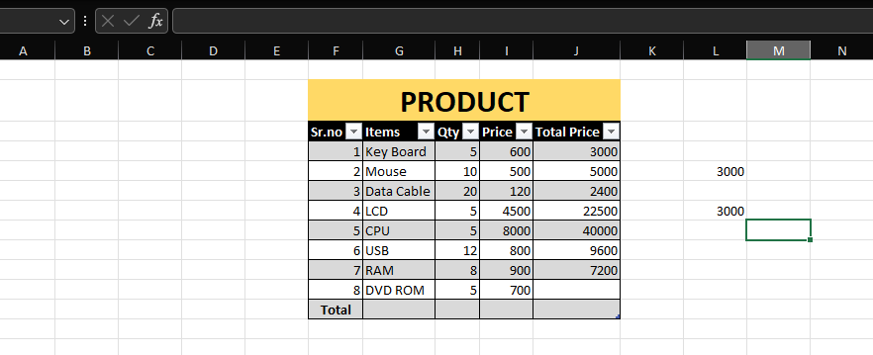

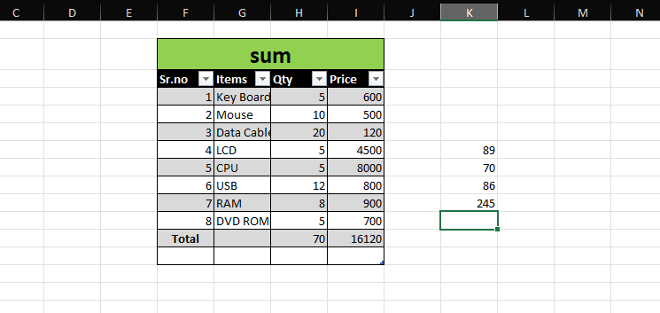

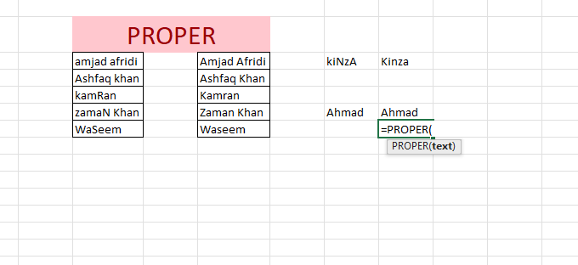

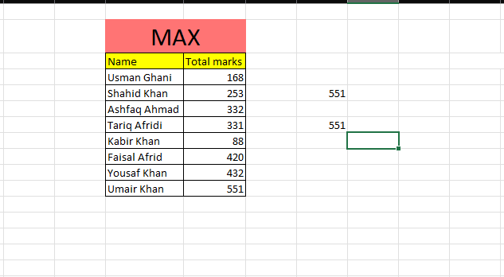

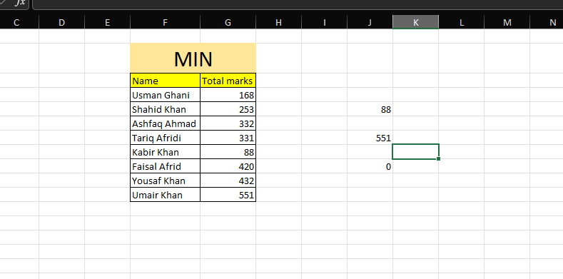

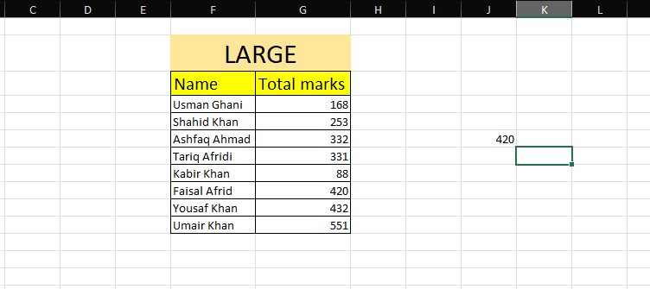

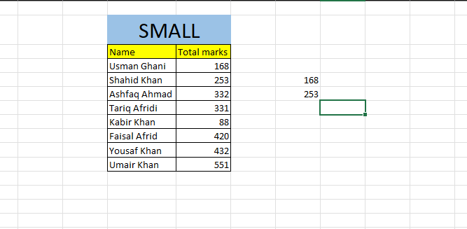

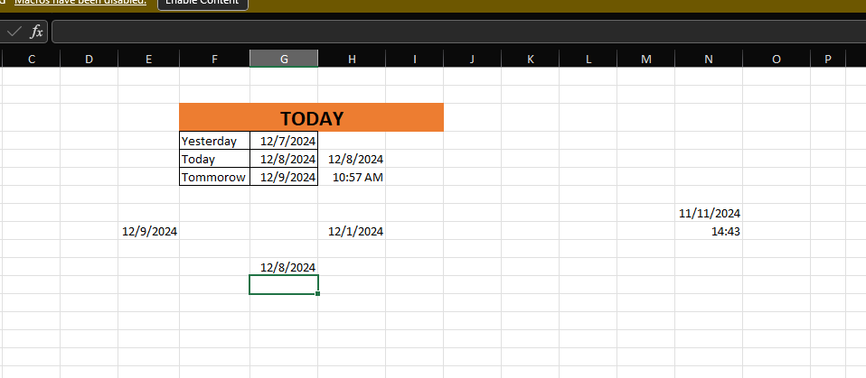

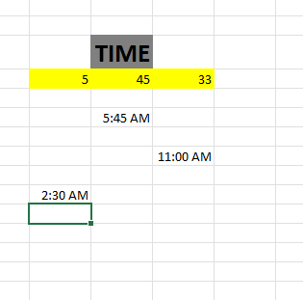

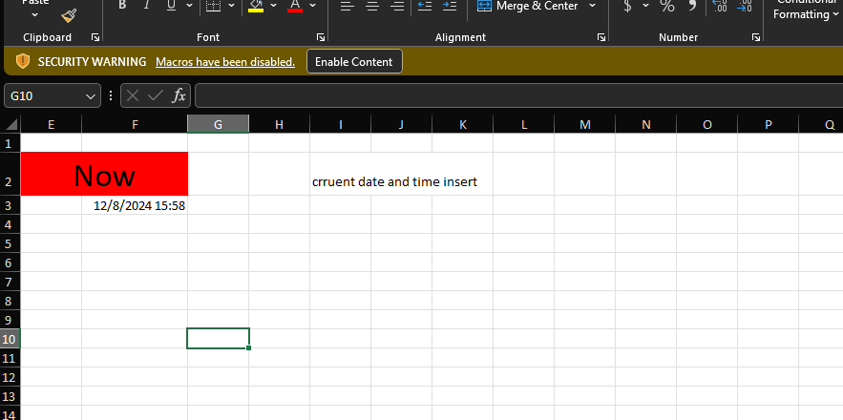

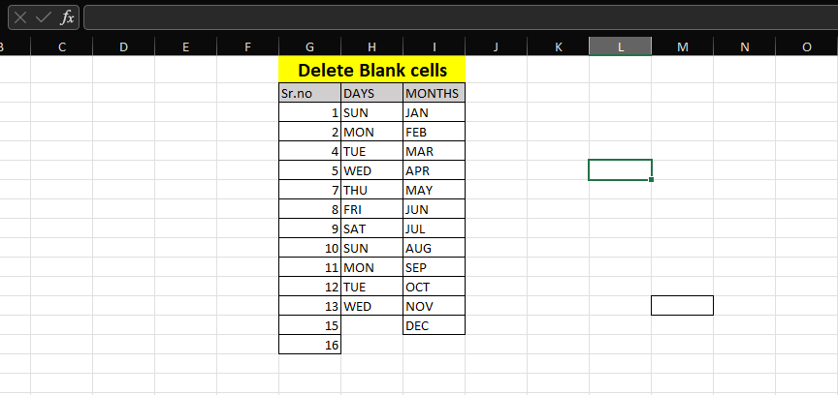

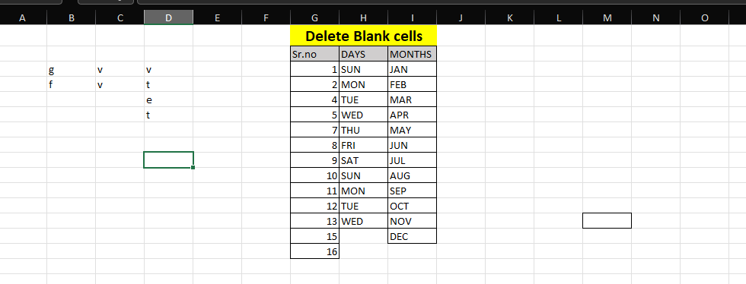

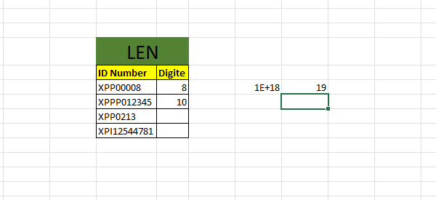

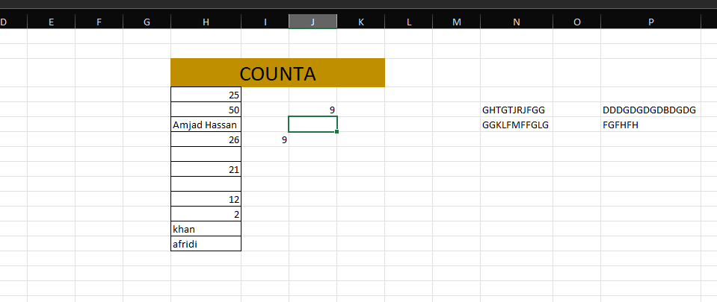

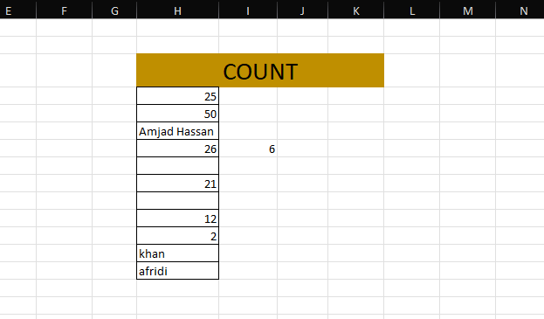

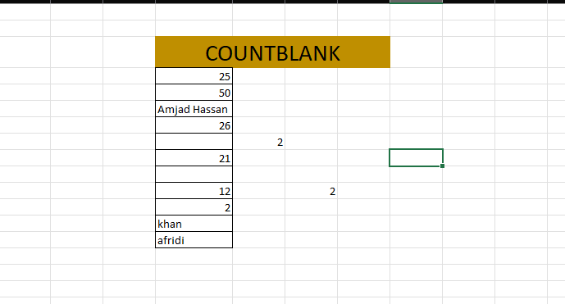

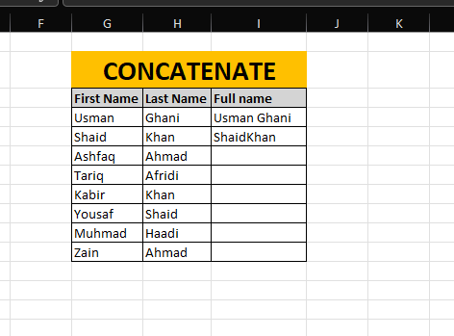

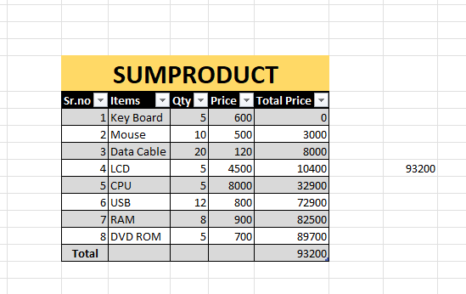

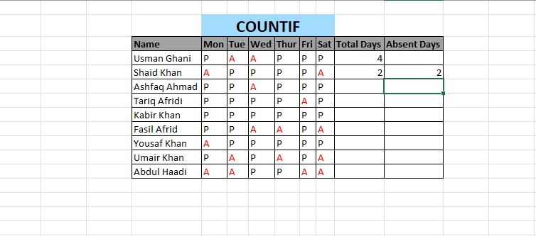

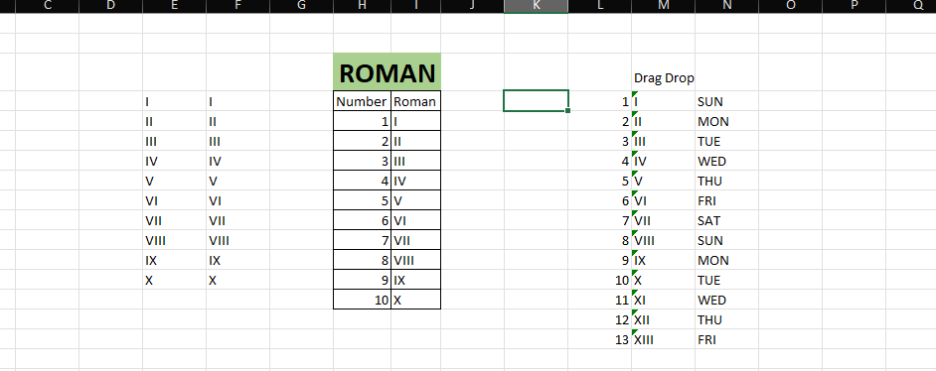

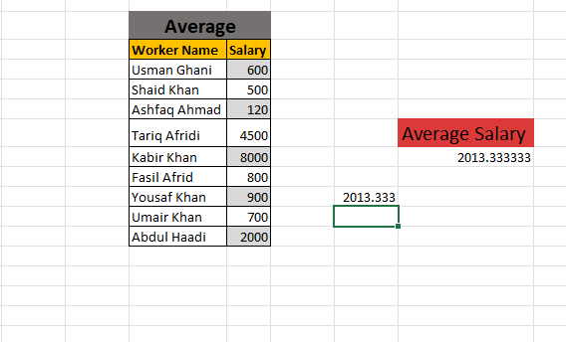

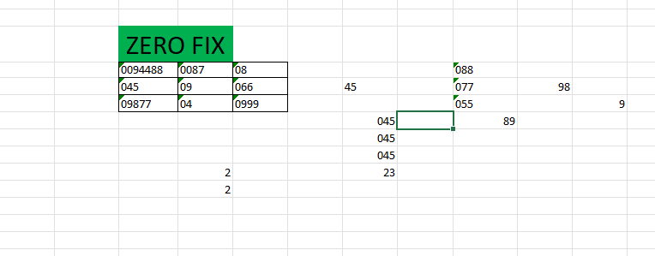

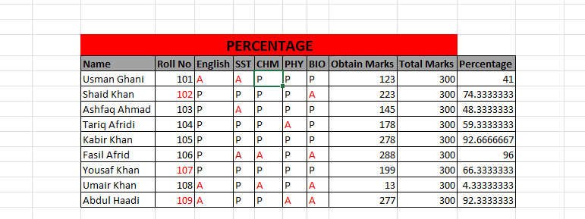

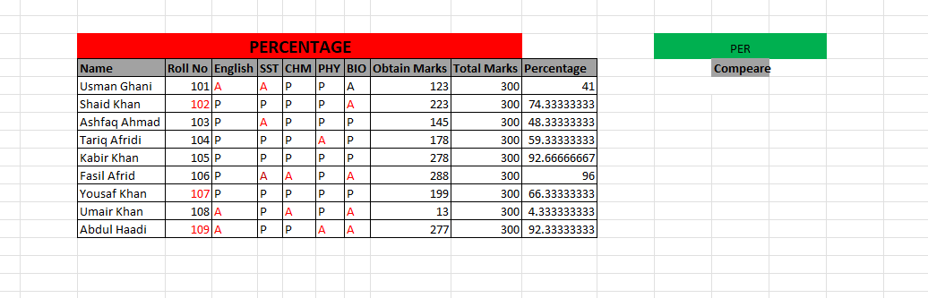

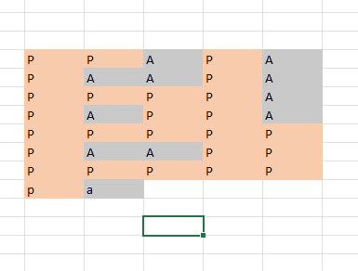

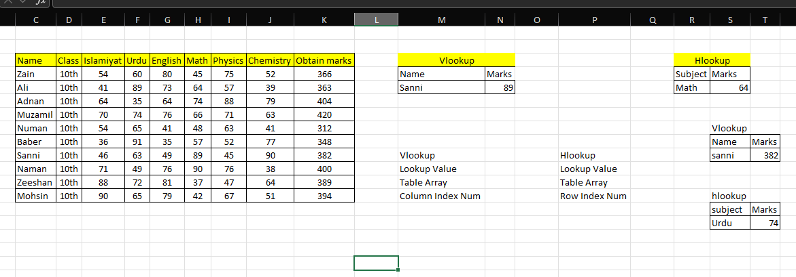

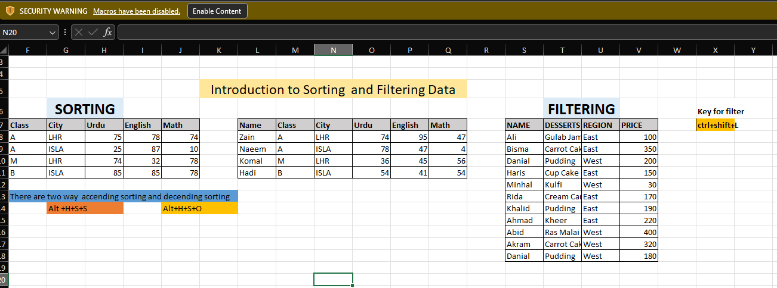

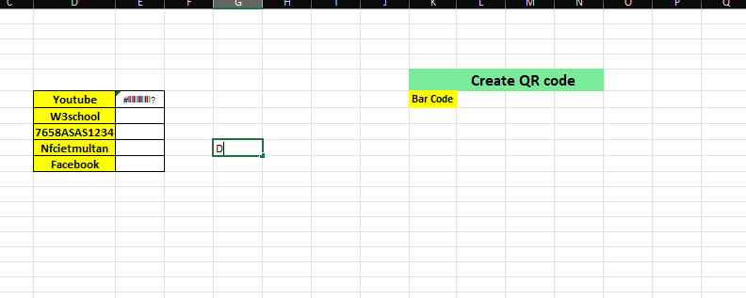

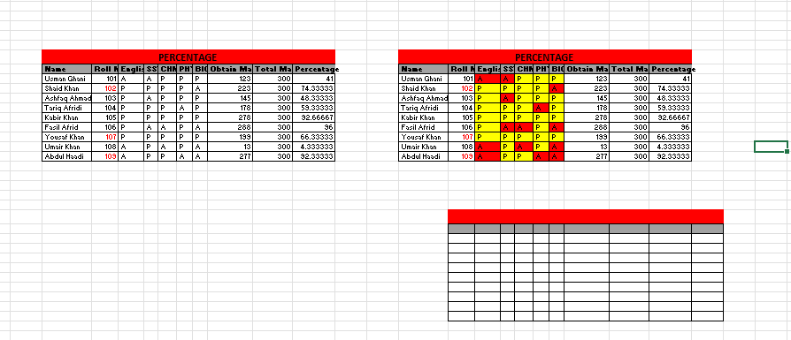

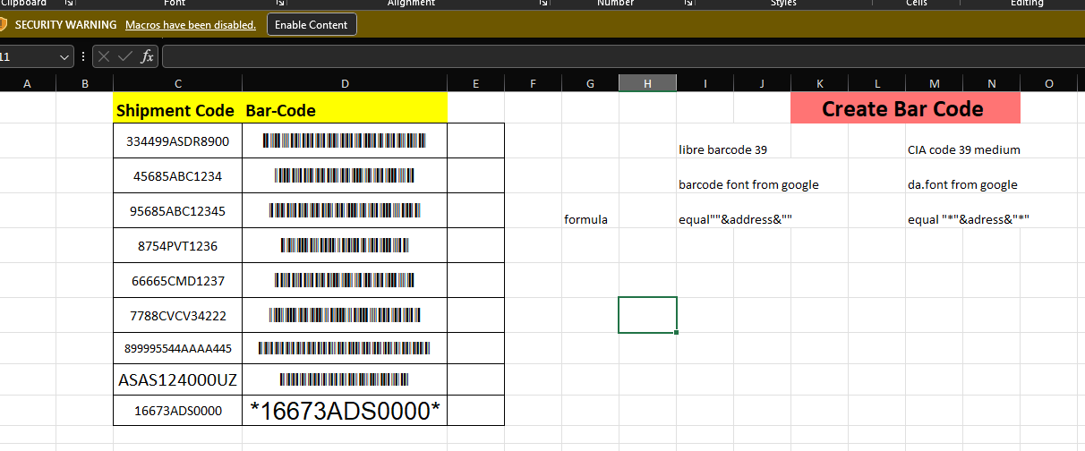

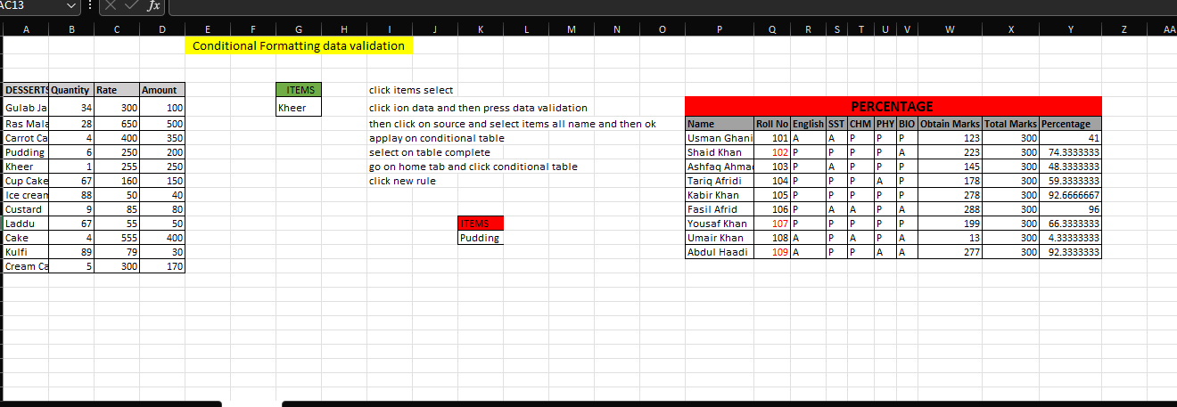

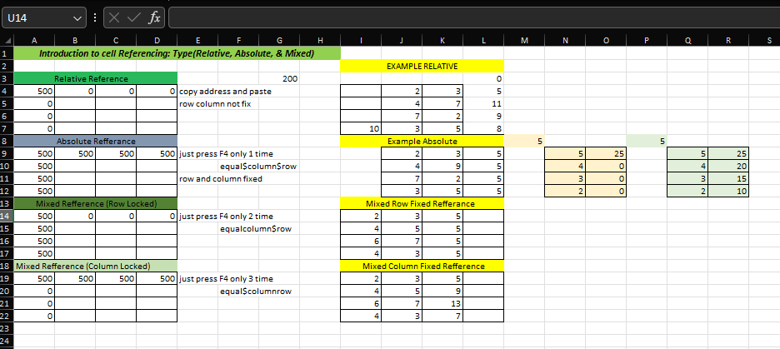

CANVA



PENCIL SOFTWARE